The following is from Appendix A of the u-Blox 6 Receiver Description including Protocol Specification. Default configuration parameters highlighted in yellow should be changed for the hike logging application. Changes are explained at the end of this document.

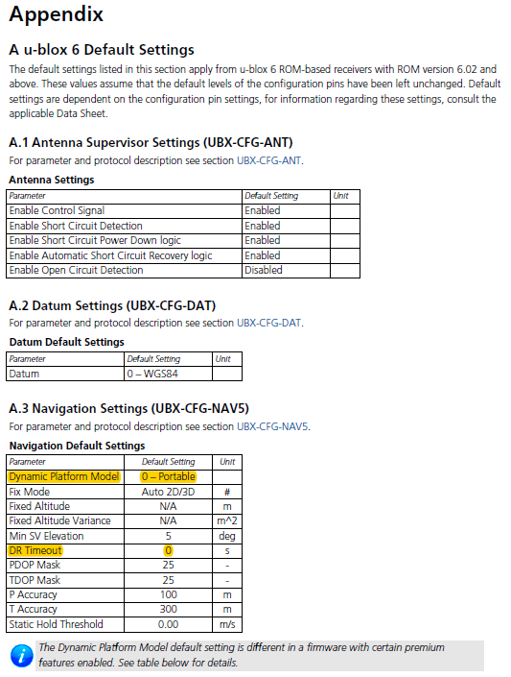

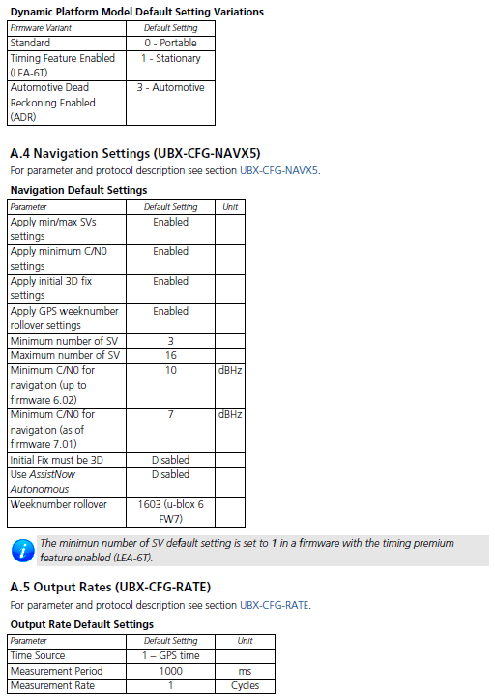

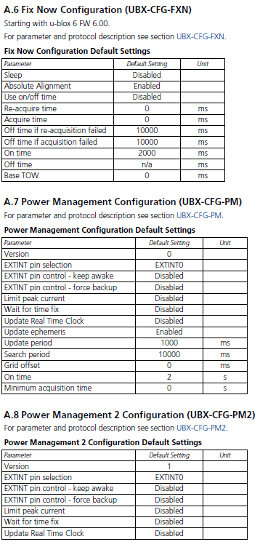

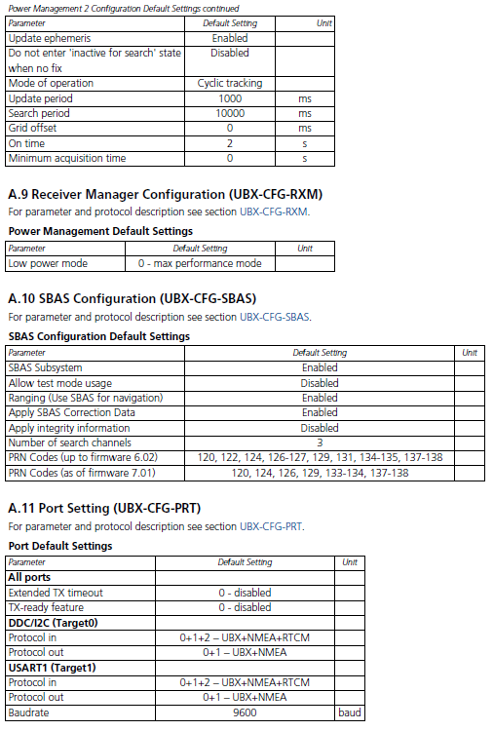

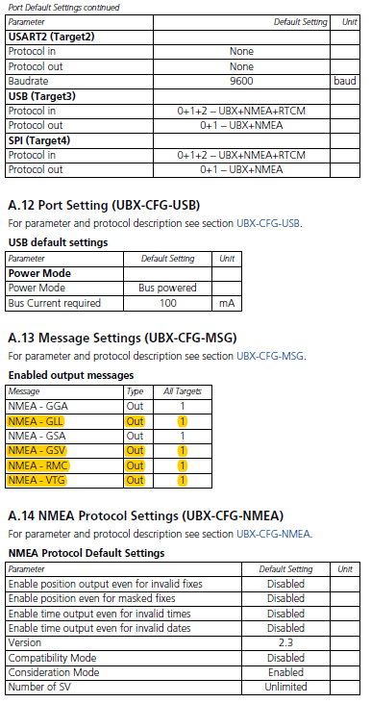

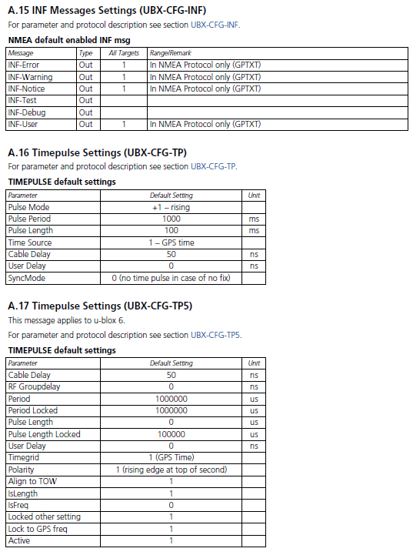

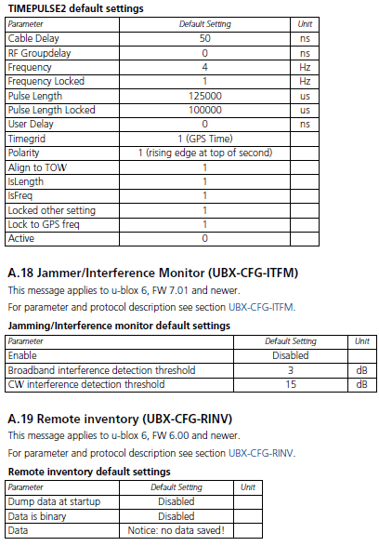

|  |  |  |  |
| --- | --- | --- | --- |
| **Default Navigation Settings (UBX-CFG-NAV5)** | | | |
| For parameter and protocol description see section UBX-CFG-NAV5. | | | |
|  | | | |
| **Parameter** | **Default Setting** | **Desired Setting** | **Unit** |
| Dynamic Platform Model | 0 – Portable | 3 -- Pedestrian |  |
| Fix Mode | Auto 2D/3D | Auto 2D/3D | # |
| Fixed Altitude | N/A | N/A | m |
| Fixed Altitude Variance | N/A | N/A | m^2 |
| Min SV Elevation | 5 | 5 | deg |
| DR Timeout | 0 | 30 | s |
| PDOP Mask | 25 | 25 | - |
| TDOP Mask | 25 | 25 | - |
| P Accuracy | 100 | 100 | m |
| T Accuracy | 300 | 300 | m |
| Static Hold Threshold | 0 | 0 | m/s |

Code to change NAV5 settings using NeoGPS library by SlashDevin:

Brute force method:

ublox::cfg_nav5_t setNav;

setNav.apply_word = 0x0009; // only change dynModel and drLimit

setNav.dyn_model = ublox::UBX_DYN_MODEL_PEDESTRIAN;

setNav.fix_mode = ublox::UBX_POS_FIX_AUTO;

setNav.fixed_alt = 0; // m

setNav.fixed_alt_variance = 10000; // 10000 * m^2

setNav.min_elev = 5; // degrees

setNav.dr_limit = 20; // s

setNav.pos_dop_mask = 250; // 10 * DOP

setNav.time_dop_mask = 250; // 10 * DOP

setNav.pos_acc_mask = 100; // m

setNav.time_acc_mask = 300; // s (although spec says "m")

setNav.static_hold_thr = 0; // cm/s

setNav.dgps_timeout = 0; // s

More readable and precise method:

// THIS COMMAND SETS THE NAV5 MODES using the more readable and precise method

ublox::cfg_nav5_t navCfg;

// set the mask bit indicating we're changing the dynamic model...

navCfg.apply.dyn_model = true

// and change the model to Pedestrian, for hikers

// note that UBX_DYN_MODEL_AIR_4G was tested on an airline flight (PHX-BWI) and works

navCfg.dyn_model = ublox::UBX_DYN_MODEL_PEDESTRIAN;

// set the mask bit indicating we're changing the ded(uced) reckoning limit...

// and change the limit to 20 s, for hikers whose signals are sometimes blocked

navCfg.apply.dr_limit = true;

navCfg.dr_limit = 20;

while (!gps.send( navCfg )) {

DEBUG_PORT.print( '.' );

delay( 500 );

}

|  |  |  |  |
| --- | --- | --- | --- |
| **Message Settings (UBX-CFG-MSG)** | | | |
| For parameter and protocol description see section UBX-CFG-MSG. | | | |
|  | | | |
| **Message** | **Default Targets & Rate** | **Desired Targets & Rate** |  |
| NMEA - GGA | All, 1 | UART 1, 1 |  |
| NMEA - GLL | All, 1 | None |  |
| NMEA - GSA | All, 1 | UART 1, 1 |  |
| NMEA - GSV | All, 1 | None |  |
| NMEA - RMC | All, 1 | None |  |
| NMEA - VTG | All, 1 | None |  |

Code to change message settings using NeoGPS library by SlashDevin:

NMEAGPS::nmea_msg_t msgType[6] =

{NMEAGPS::NMEA_GGA, NMEAGPS::NMEA_GLL, NMEAGPS::NMEA_GSA, NMEAGPS::NMEA_GSV, NMEAGPS::NMEA_RMC, NMEAGPS::NMEA_VTG};

uint8_t rate[6] = {1, 0, 1, 0, 0, 0};

int maxI = (sizeof(msgType)/sizeof(NMEAGPS::nmea_msg_t));

for (int i = 0; i < maxI; i++) {

Serial.print(F("Setting message type "));

Serial.print(msgType[i]);

Serial.print(F(" to rate "));

Serial.println(rate[i]);

while (!ublox::configNMEA(gps, msgType[i], rate[i])) {

Serial.print( '.' );

delay( 500 );

}

Serial.println();

}

***Also, in NMEAGPS_cfg.h of SlashDevin’s NeoGPS library***, make sure NMEAGPS_PARSE_SATELLITES, NMEAGPS_PARSE_GGA, NMEAGPS_PARSE_GSA, NMEAGPS_COMMA_NEEDED, and LAST_SENTENCE_IN_INTERVAL NMEAGPS::NMEA_GSA are #defined, consistent with the message types enabled by the code above.

***In GPSfix_cfg.h of SlashDevin’s NeoGPS library***, comment/uncomment the #defines as shown below:

//#define GPS_FIX_DATE

#define GPS_FIX_TIME

#define GPS_FIX_LOCATION

//#define GPS_FIX_LOCATION_DMS

#define GPS_FIX_ALTITUDE

//define GPS_FIX_SPEED

//#define GPS_FIX_VELNED

//define GPS_FIX_HEADING

#define GPS_FIX_SATELLITES

#define GPS_FIX_HDOP

#define GPS_FIX_VDOP

//#define GPS_FIX_PDOP

//#define GPS_FIX_LAT_ERR

//#define GPS_FIX_LON_ERR

//#define GPS_FIX_ALT_ERR

//#define GPS_FIX_GEOID_HEIGHT